CH.VAMSI KRISHNA

192111558

**COMPUTER NETWORKS LAB EXPERMIENTS**

**DAY-3**

1. Simulating X, Y, Z Company Network Design

AIM : to Simulating X, Y, Z Company Network Design in packet tracer

step1:-first take core router

step2:-link that router with distributers and switchs and connect with pc’s and printer and server

step3:-connect that connect with pc’s and printer and server to the switchs

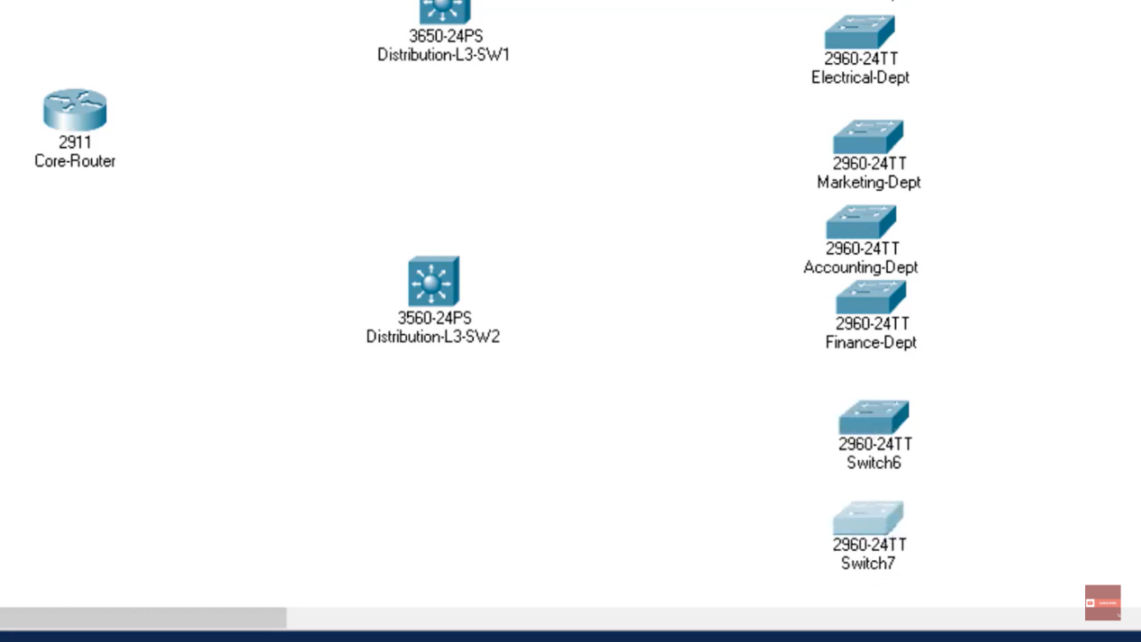

step4:- after connection connect with pc’s and printer and server with connection of tablet Check the connection with the appliances of the server

step5:- if command send correctly you got successfull other wise recheck the connections

Step6:- then the Simulating X, Y, Z Company Network Design in packet tracer was simulated by using the switchs , routers , pc’s , servers it was simulated

